**Create Wallet and do Transaction**

Go to <https://bitnifty.network/faucet> Click on “Add token to wallet”

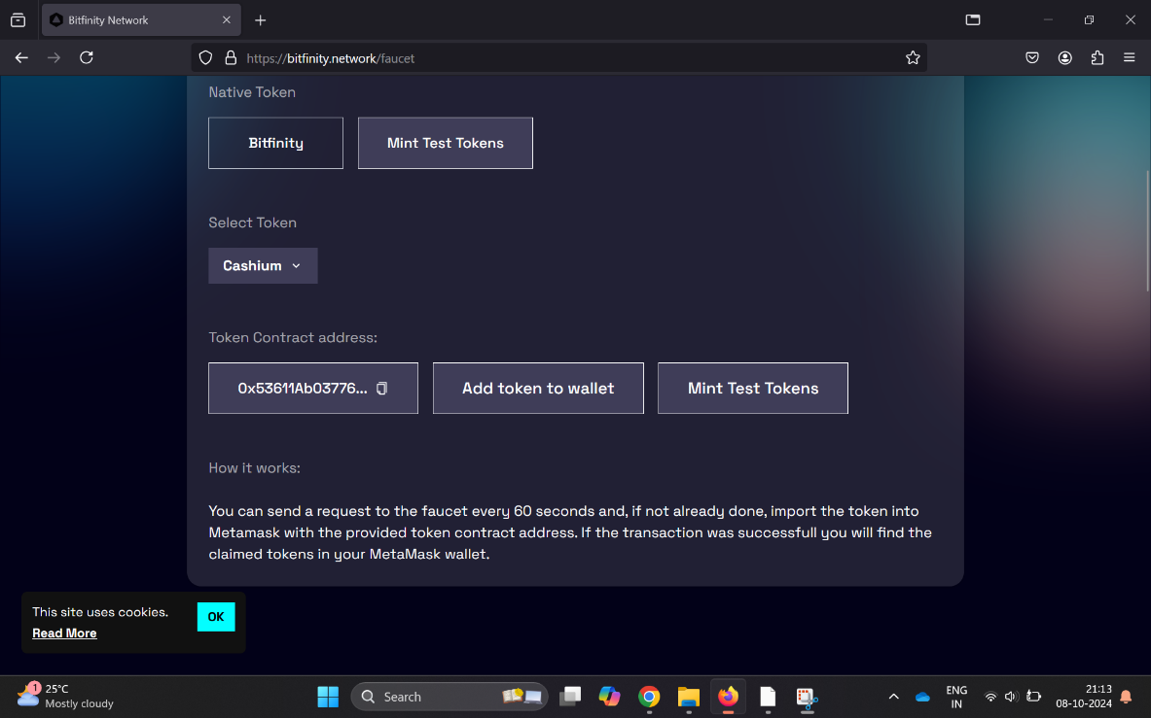

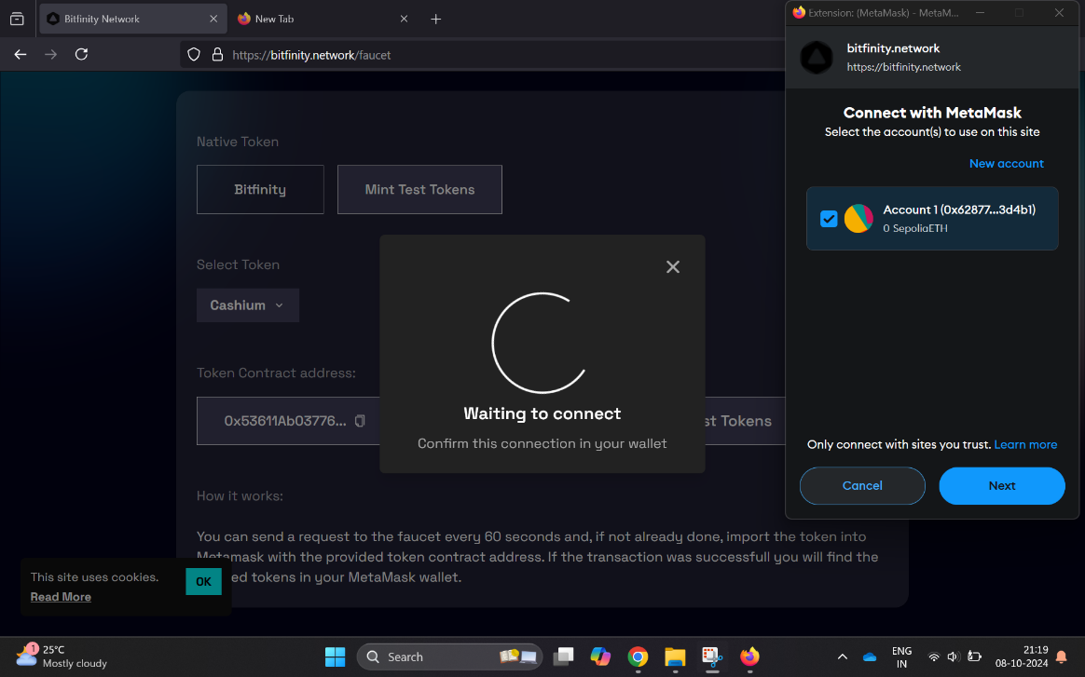

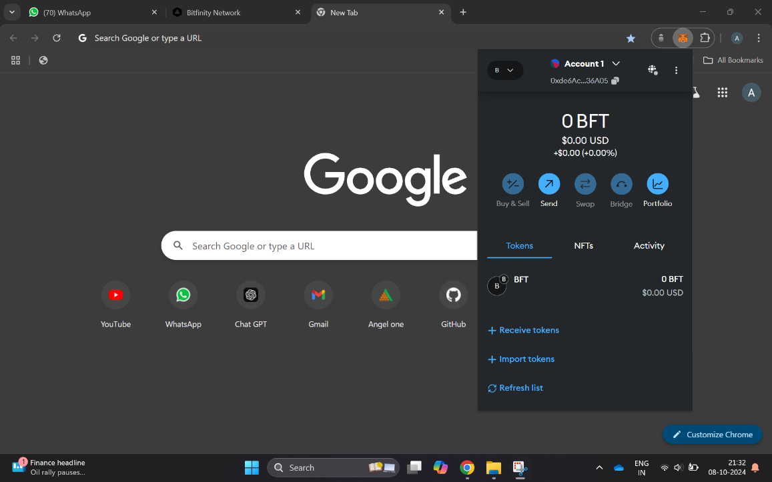

Click on “Mint Test Tokens” and you will have 1 BFT in your account

Click on “Send” and add address of receiver

